
KARNATAKA STATE COUNCIL FOR SCIENCE AND TECHNOLOGY
Indian Institute of Science campus, Bengaluru
Telephone: 080 – 23341652, 23348848 || Email: spp@kscst.org.in
Website: www.kscst.org.in/spp.html or https://kscst.karnataka.gov.in/en
FORMAT FOR STUDENT PROJECT PROPOSAL FOR THE
49th SERIES OF STUDENT PROJECT PROGRAMME

Name of the College:
Ballari Institute of Technology and Management
Project Title:
Non-Invasive Blood Group Detection Using Fingerprint
Branch:
Computer Science and Engineering
Theme:
Non-Invasive Blood Group Detection Using Fingerprint and Deep Learning.
Name(s) of project guide(s):
Name: Dr. C. K. Srinivas
Email id: srinivasck9@bitm.edu.in
Contact No.: 9886684832

Name of Team Members :

Name: POORVI H
USN No.: 3BR22CS120
Email id: poorvih7469@gmail.com
Mobile No:9036717627
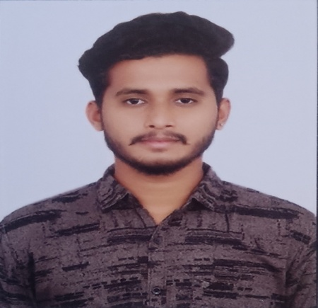
Name: PRAGNA A
USN No.: 3BR22CS122
Email id: pragnaacharya78@gmail.com
Mobile No.: 9449077739

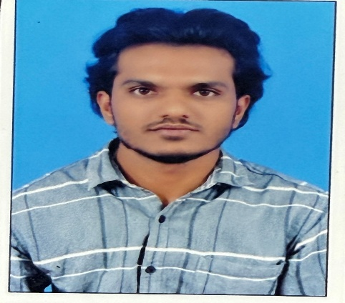

Name: RAJESHWARI
USN No.: 3BR22CS136
Email id: rajeshwarikurkunda@gmail.com
Mobile No.: 8746879913
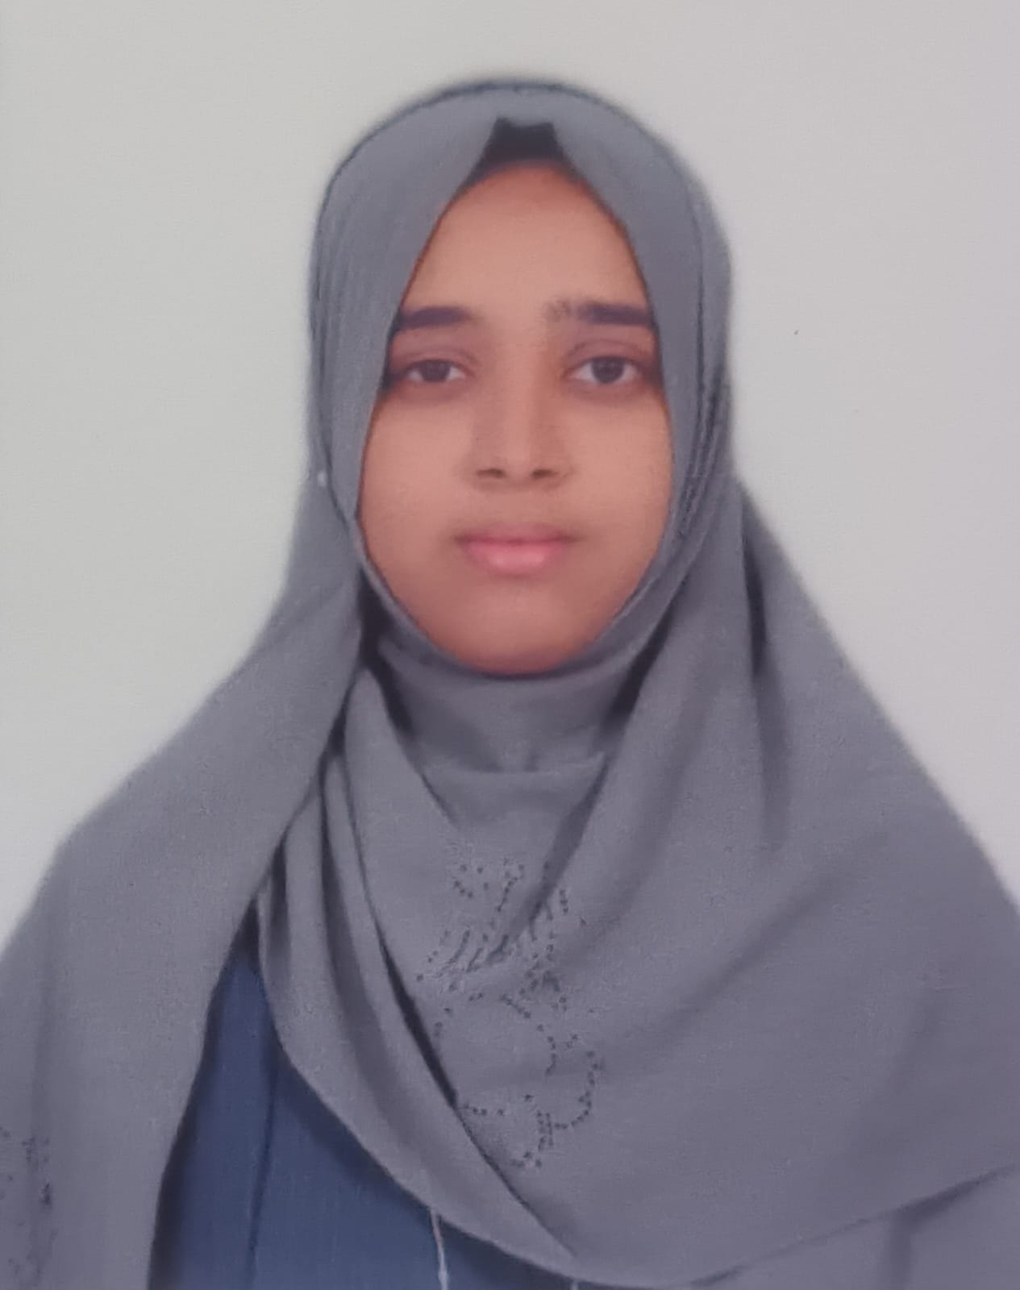
Name: B. FOUZIYA
USN No.: 3BR23CS402
Email id: bfouziyacs008@gmail.com
Mobile No.: 9731988327
Team Leader of the Project:
Name: PRAGNA A
USN No.: 3BR22CS122
Email id: pragnaacharya78@gmail.com
Mobile No.: 9449077739
Processing Fee Details (Through Online Payment only):
(processing fee of Rs. 1180/-)
- BANK REF. NO. / UTR NO. / UPI No. (12 digits) | : | UTR:505665036060
- TRANSACTION ID | : | T2512131122364582979103
- NAME OF THE SENDER / ACCOUNT HOLDER and CONTACT NUMBER | : | Mohammad mj  7411142547
- NAME OF THE BANK | : | INDIAN POST PAYMENT BANK
- PROCESSING FEES | : | Rs. 1,180/- (Inclusive of 18% GST)
- DATE OF PAYMENT MADE | : | 13/12/2025
- TIME | : | 11:22 am
- MODE OF PAYMENT MADE  (NEFT / UPI, PLEASE SPECIFY) | : | UPI (Phone pay)
Date of commencement of the Project:
17/02/2025
Probable date of completion of the project:
30/05/2026

Timeline Structure
Task | Start Date | End Date | Duration | Milestone achievable
Project Initiation | 17-03-2025 | 10-05-2025 | 8 Weeks | Title Selection
Research Phase | 15-05-2025 | 13-08-2025 | 12 Weeks | Literature Survey, Project Synopsis, Presentation
Development Phase | 30-08-2025 | 05-01-2026 | 12 Weeks | Design part, Project development, Demo Model
Testing Phase | 15-01-2026 | 10-02-2026 | 4 Weeks | Unit, Integration & System Testing
Submission of PPT and Abstract to KSCST for conducting mid-term evaluation  (Upload to Google Form) | Middle of March – 2nd Week of April 2026
Final Review | 17-03-2026 | 30-05-2026
Project Submission | 17-03-2026 | 30-05-2026
Submission of Project Completion Report to KSCST (Upload to Google Form) | April / May 2026

Scope / Objectives of the project:

Objectives
- To design a non-invasive system that predicts an individual’s blood group using fingerprint images instead of traditional blood samples.
- To apply advanced CNN architectures like ResNet for extracting deep fingerprint features and performing blood group classification.
- To provide a fast, painless, and user-friendly alternative to conventional blood testing methods.
- To develop a scalable model that can be integrated into healthcare diagnostics, biometric identification systems, and blood donation platforms.

Methodology:
- Data Collection
Fingerprint images are collected from individuals along with their corresponding blood group labels, ensuring ethical compliance and data privacy.
- Data Preprocessing
The collected fingerprint images are resized, normalized, and enhanced to remove noise and improve ridge clarity. Data augmentation techniques are applied to increase dataset diversity.
- Feature Extraction
Distinctive fingerprint patterns such as ridge flow and texture features are automatically extracted using Convolutional Neural Networks (CNN).
- Model Selection and Architecture
A deep learning model based on the ResNet architecture is employed to learn complex patterns from fingerprint images and avoid vanishing gradient problems.
- Model Training
The preprocessed dataset is split into training, validation, and testing sets. The model is trained using labeled data with appropriate loss functions and optimization techniques.
- Blood Group Classification
The trained model classifies fingerprint images into corresponding blood group categories (A, B, AB, O with Rh factor).
- Model Evaluation
Performance is evaluated using metrics such as accuracy, precision, recall, F1-score, and confusion matrix.
- Result Analysis and Deployment
The results are analyzed, and the trained model can be integrated into a user-friendly application for real-time, non-invasive blood group detection.
Expected Outcome of the project:
- Demonstration of the feasibility of non-invasive blood group detection using fingerprint images and deep learning techniques.
- Development of a prototype ResNet-based CNN model capable of learning fingerprint patterns associated with blood groups.
- Achieving moderate classification accuracy, indicating a correlation between fingerprint features and blood group types rather than definitive identification.
- Identification of key limitations such as dataset size, image quality, and biological variability affecting prediction performance.
- Establishment of a baseline framework for future research and improvement using larger datasets and advanced models.
Is the project proposed relevant to the Industry / Society or Institution?

Yes / No:
Yes
The project is relevant to industry, society, and institutions as it supports innovation in non-invasive healthcare diagnostics and biometric research, addressing the need for faster and safer identification methods.
Can the product or process to be developed in the project be taken up for filing a Patent?
Yes / No:
Yes
Prior Art search done?
Yes/No:
No

Budget details (break-up details should be given):
Note: KSCST will provide nominal grant support for carrying out the project by students if selected by the project selection committee.
Budget | Amount
a) Materials / Consumables (Please specify)  The project uses several essential components, including an MQ-2 gas sensor, a pressure sensor, and a DHT11/LM35 temperature sensor for monitoring gas concentration, pressure variations, and temperature changes in real time. An Arduino Uno or ESP32 microcontroller, along with a NodeMCU (ESP8266) module, manages data processing and wireless communication. Additional items such as power supply components, wiring, PCB, and connectors ensure proper hardware integration and stable system operation. | 4000
b) Labor (Describe) | 0.00
c) Travel (Describe) multiple field visits to rural areas for on-site inspection and validation of the system. These visits were necessary to observe real pipeline conditions, test the sensors in practical environments, and verify the operational accuracy of the anomaly detection system during actual usage scenarios. | 2500
e) Miscellaneous (Please specify) Miscellaneous expenses include the purchase of supporting components such as jumper wires, casing materials, and minor accessories required for assembling and testing the system. These items were essential for ensuring proper hardware integration, safe enclosure, and smooth functioning of the overall setup. | 500
Total | 7000

Any other technical details (Please specify):
Use of CNN-based ResNet architecture, fingerprint image preprocessing and augmentation, supervised learning with labeled datasets, performance evaluation using standard classification metrics, and implementation using Python with deep learning libraries.
SPP Coordinator (Identified by the college):
Name: Mr T.M Hayath
Email id:
Contact No.: 9535850340

(Name & Signature of  SPP Coordinator with Seal)  Mr T.M Hayath  Email id:  Contact No:9535850340 | Name and signature of the  Project Guide with Seal:  Dr. C. K. Srinivas  Email id: srinivasck9@bitm.edu.in  Contact No:9886684832

DECLARATION
(From Project Students)
(To scan this page and enclose in the project proposal)

We, the project team hereby declare that the details enclosed in the project proposal (Title of the Project: REAL-TIME PIPELINE ANOMALY DETECTION USING IOT SENSOR AND MACHINE LEARNING, Branch: ARTIFICIAL INTELLIGENCE AND MACHINE LEARNING College: BALLARI INATITUTE OF TECHNOLOGY AND MANAGEMENT are true and correct to the best of our knowledge and belief. We undertake to inform the Karnataka State Council for Science and Technology (KSCST) of any changes to the project title or team members' names immediately through our project guide or the SPP Coordinator of our institution.
Additionally, we declare that the project work is original and not a result of copying or purchasing. We are committed to completing the project independently, with support from our faculty and project guide, while utilizing the facilities provided by the college. We will not engage in plagiarism and pledge to be sincere and dedicated in executing and completing the project as proposed.
We understand that if any of the above information is found to be false, untrue, or misleading, we may be held liable. We authorize the sharing of the project information contained in this proposal with KSCST, Bengaluru.
We acknowledge that the project team must exhibit and demonstrate the project, participate in the mid-term evaluation of sanctioned projects, and engage with experts. Additionally, we must exhibit the project at the Annual State-Level Poster Presentation and Exhibition, if selected. Should our team fail to participate in the mid-term evaluation or the Annual Exhibition (if selected), we understand that the supported project funds will be returned to KSCST.
We also enclose the endorsement form for KSCST, Bengaluru.
Name of the students with USN No. Signature with date
1. K VARUN(3BR22AI071)
2. KIRAN GOUDA V(3BR22AI087)
3. MUHAMMAD JUNAID(3BR22AI102)
4. MOHAMMAD SAKIB(3BR22AI110)
(Name & Signature of  SPP Coordinator with Seal)  DR. YADAVALLI BASAVARAJ | Name and signature of the  Project Guide with Seal:  MRS. KAVYA SREE K
Email id: yadavallibasavaraj@bitm.edu.in | Email id: kavyasree.k@bitm.edu.in
Contact No.: 9448755268 | Contact No.: 9482880786
ENDORSEMENT
(From College, endorsement to be taken in the institution / Department Letter head)
(To scan this page and enclose in the project proposal)

This is to certify that 1) Mr. K VARUN 2) Mr. KIRAN GOUDA V
3) Mr. MUHAMMAD JUNAID 4) Mr. MOHAMMAD SAKIB are bonafide student(s) of Department of ARTIFICIAL OF INTELLIGENCE AND MACHINE LEARNING in the degree program of our institution. If the project proposal submitted by these students under the 49th series of Student Project Programme is selected by KSCST, we will provide the requisite laboratory / Computer / infrastructure support in our college / Institution. Further we also take necessary steps to see that the project team will exhibit / demonstrate their project in the mid-term evaluation of project and in the Annual State-Level Poster Presentation and Exhibition (if selected). If the student team fails to send the completed project report or fails to attend the evaluation in mid-term evaluation of sanctioned projects or fails to attend the Annual State-Level Poster Presentation and Exhibition (if selected), the supported project amount will be returned to KSCST.
MRS. KAVYA SREE K  (Name & Signature of  Project Guide with Seal) | Dr B M VIDYAVATHI  (Name & Signature of  HoD with Seal) | DR.YADAVALLI BASAVARAJ  (Signature of Principal  with Seal)
Email id:  kavyasree.k@bitm.edu.in | Email id:  vidyavathi@bitm.edu.in | Email id:  yadavallibasavaraj@bitm.edu.in
Contact No.: 9482880786 | Contact No.: 9449622973 | Contact No.: 9448755268

DETAILS OF PROCESSING FEES MADE THROUGH
NEFT / UPI PAYMENT
(Note: Include this page in the softcopy of the student project proposal. The student team shall furnish the details in the Google Form. It is informed to the students to 1) keep ready the softcopy of the project proposal and other documents and 2) Furnish the payment made details as processing fees and 3) update the details in the Google Form on the same day of payment made to KSCST by NEFT / UPI payment).
For finance related queries, please contact KSCST accounts section: 080 – 23341652, 23348848, email: finance@kscst.org.in

- TITLE OF THE PROJECT | : | REAL-TIME PIPELINE ANOMALY DETECTION USING IOT SENSOR AND MACHINE LEARNING
- NAME OF THE TEAM LEADER | : | KIRAN GOUDA V
- EMAIL ID | : | Kirangoudav@gmail.com
- CONTACT MOBILE NO. | : | 7892373318
PAYMENT MADE DETAILS
- BANK REF. NO. / UTR NO. / UPI No. (12 digits) | : | UTR:505665036060
- TRANSACTION ID | : | T2512131122364582979103
- NAME OF THE SENDER / ACCOUNT HOLDER and CONTACT NUMBER | : | Mohammad mj  7411142547
- NAME OF THE BANK | : | INDIAN POST PAYMENT BANK
- PROCESSING FEES | : | Rs. 1,180/- (Inclusive of 18% GST)
- DATE OF PAYMENT MADE | : | 13/12/2025
- TIME | : | 11:22 am
- MODE OF PAYMENT MADE  (NEFT / UPI, PLEASE SPECIFY) | : | UPI (Phone pay)

(Name & Signature of  the team leader) | (Name & Signature of  Project Guide / SPP Co-ordinator HOD withSeal)
KARNATAKA STATE COUNCIL FOR SCIENCE AND TECHNOLOGY
Indian Institute of Science campus, Bengaluru
49th SERIES OF STUDENT PROJECT PROGRAMME (SPP)
(Note: This page is for information about bank details of KSCST to the student team and college / institution and not to include this page in the project proposal softcopy)

BANK ACCOUNT DETAILS OF KSCST
Name and address of the Institution | Karnataka State Council for Science and Technology, IISc Campus, Bangalore -560012
Account holder’s name / Designation | Secretary, Karnataka State Council for Science and Technology
Bank Account No. & Name of the bank | Current A/C No. 0683201000024  Canara Bank, IISc Campus Branch, Bangalore-560012
IFSC Code | CNRB0000683
MICR Code | 560015023
Bank Branch Address | Canara Bank, Indian Institute of Science, Bangalore-560012

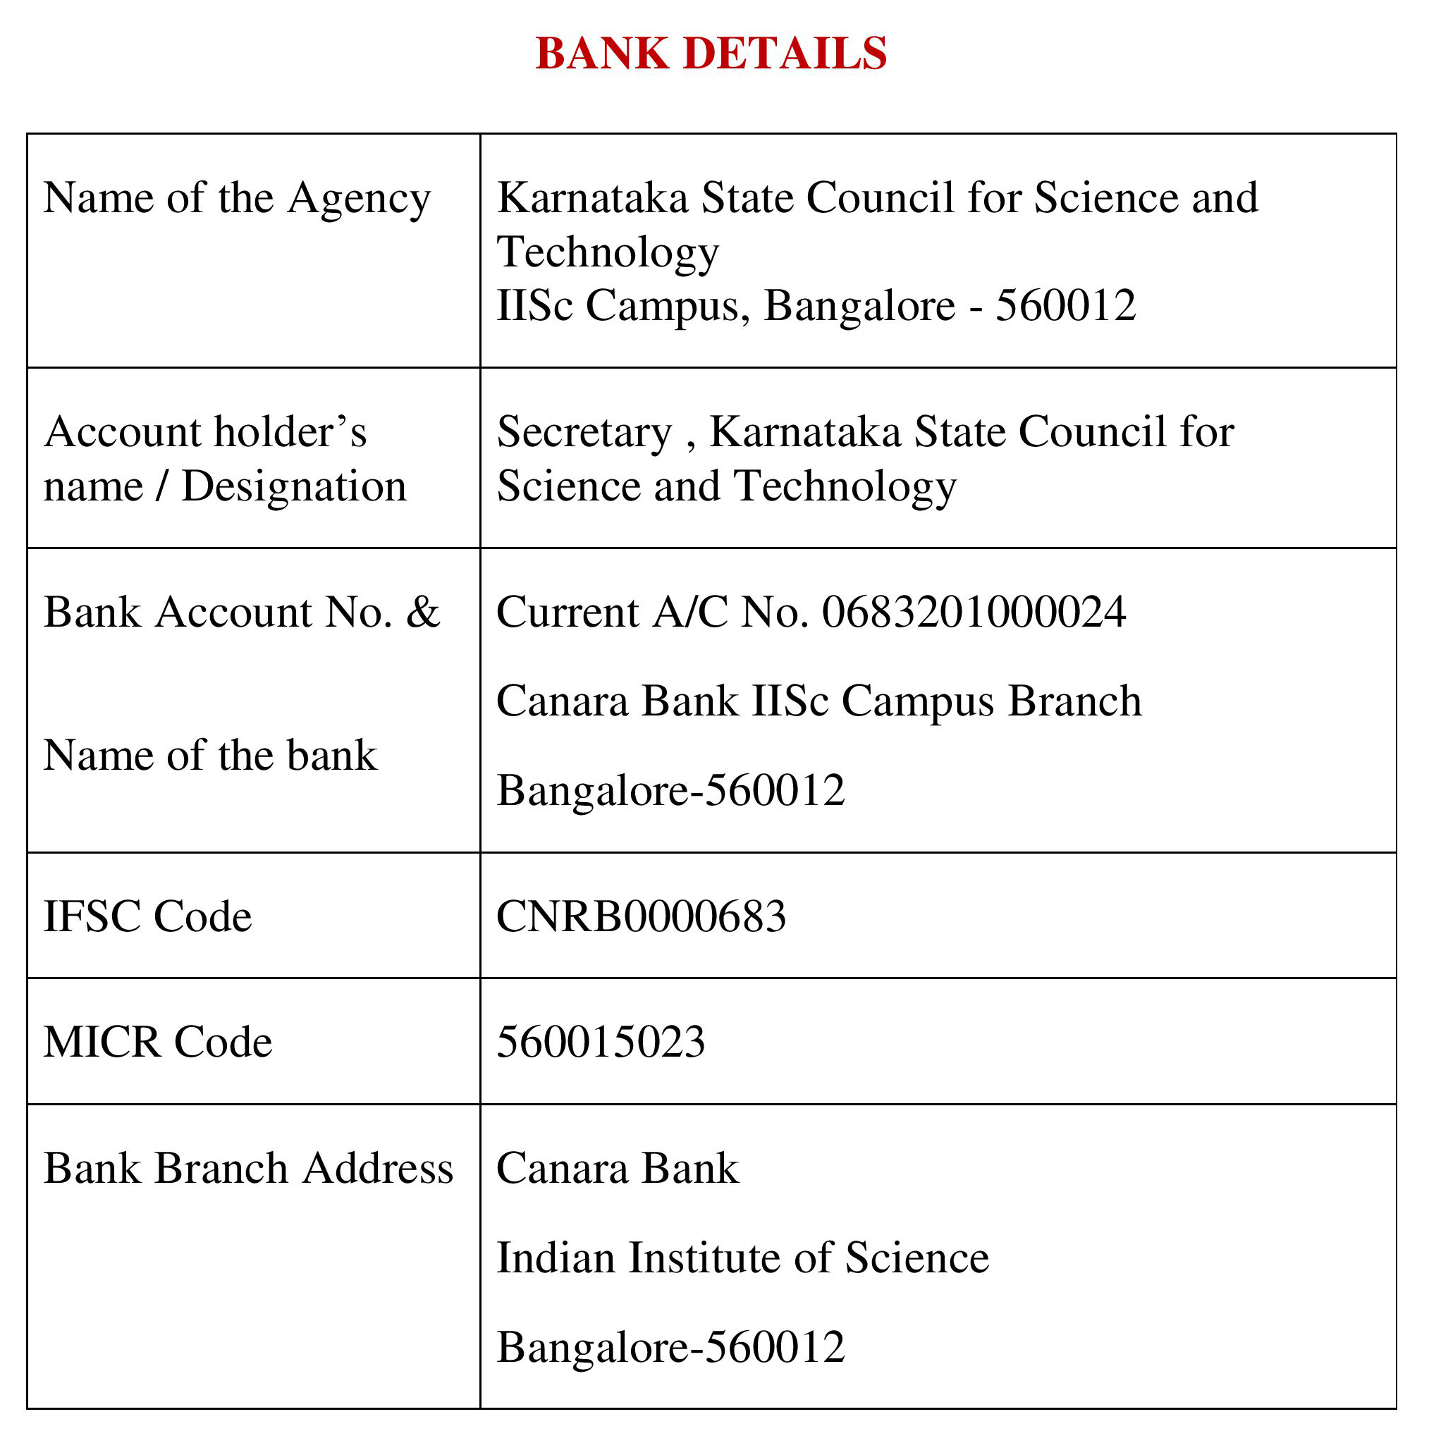
Note: For finance related queries, please contact KSCST accounts section: 080 – 23341652, 23348848 during office hours between 3.00 pm to 5 pm, email: finance@kscst.org.in with a copy to spp@kscst.org.in
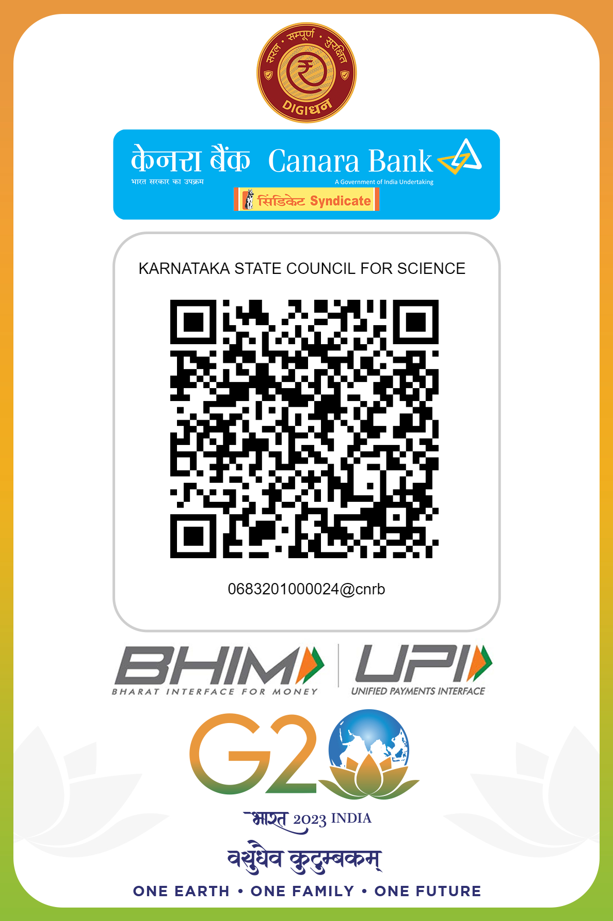
Note: For finance related queries, please contact KSCST accounts section: 080 – 23341652, 23348848 during office hours between 3.00 pm to 5 pm, email: finance@kscst.org.in with a copy to spp@kscst.org.in

